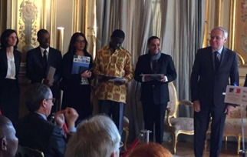

Tomorrow's Foundation, was rewarded the Human Rights Prize of the French Republic for its efforts and contributions in the field of protection of Human Rights of disabled persons in India by the Commission National Consultative des Droits de l'Homme (National Consultative Commission on Human Rights ,CNCDH),France.
The award was presented by Mr Jean-Marc Ayrault, Minister of Foreign Affairs and International Development - Paris, France to the Co-founder of Tomorrow's Foundation Mr. Arup Ghosh. The Rights Award ceremony was held in Paris on 15th of December 2016 to acknowledge the commendable work done by the Foundation with disabled children. Four NGO's internationally got the award among 182 Projects.

