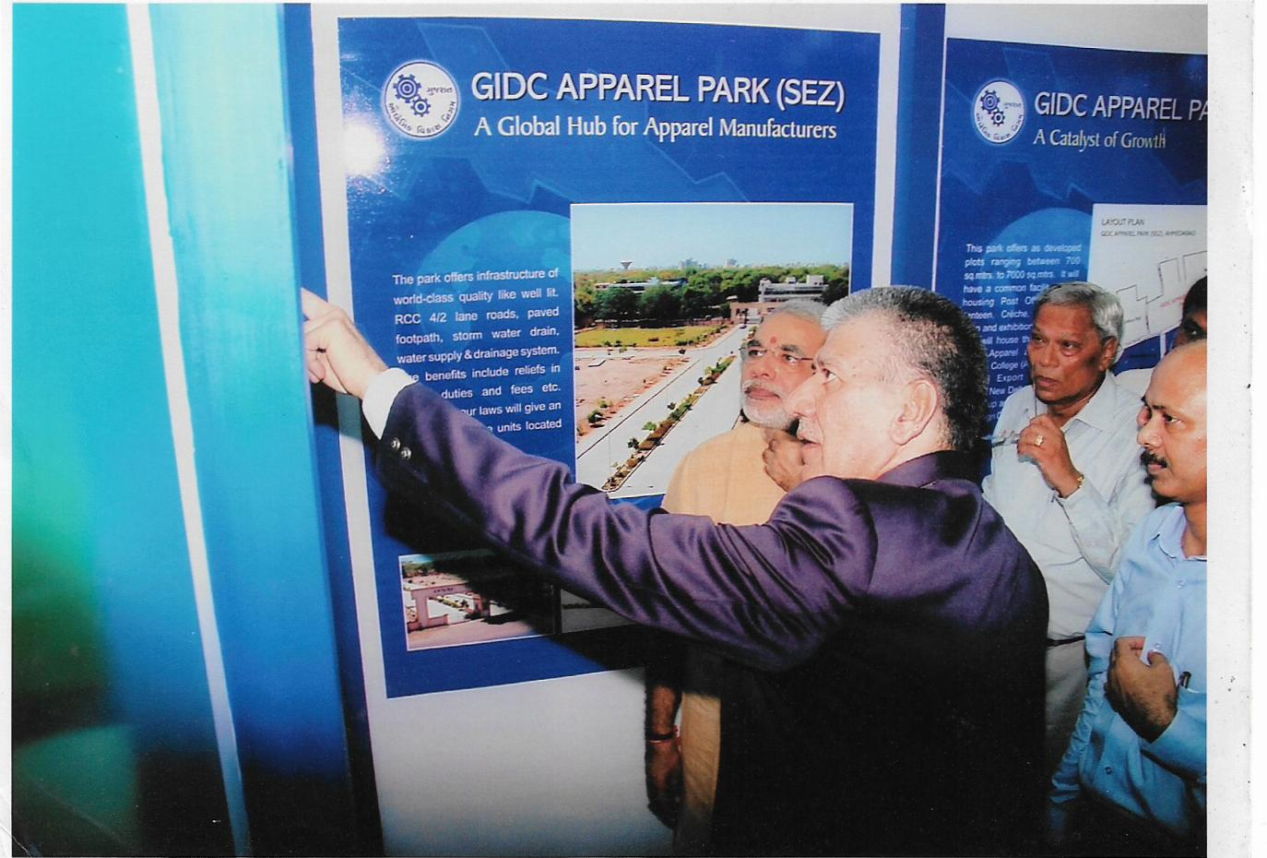
Inauguration of ALT Training College Ahmedabad
by Shri Narendra Bhai Modi
Honorable Prime Minister of India

