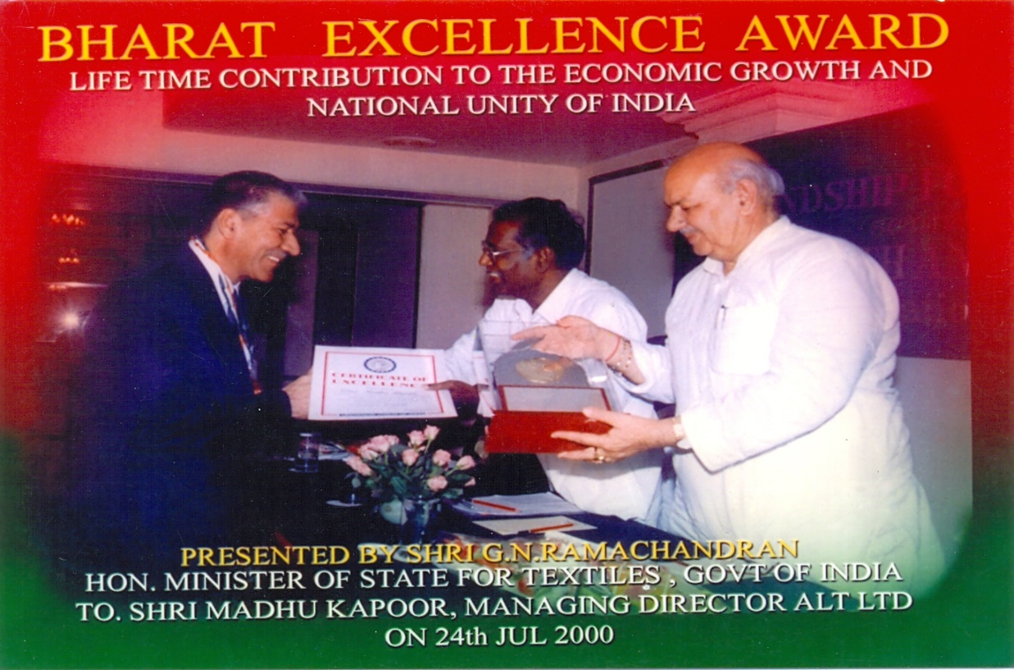
BHARAT EXCELLENCE AWARD
Presented by Shri G. N RAMACHANDRAN
Hon.Minister of Textiles, Govt of INDIA
To Shri Madhu Kapoor, Managing Director, ALT LTD ON 24 JULY 2000

