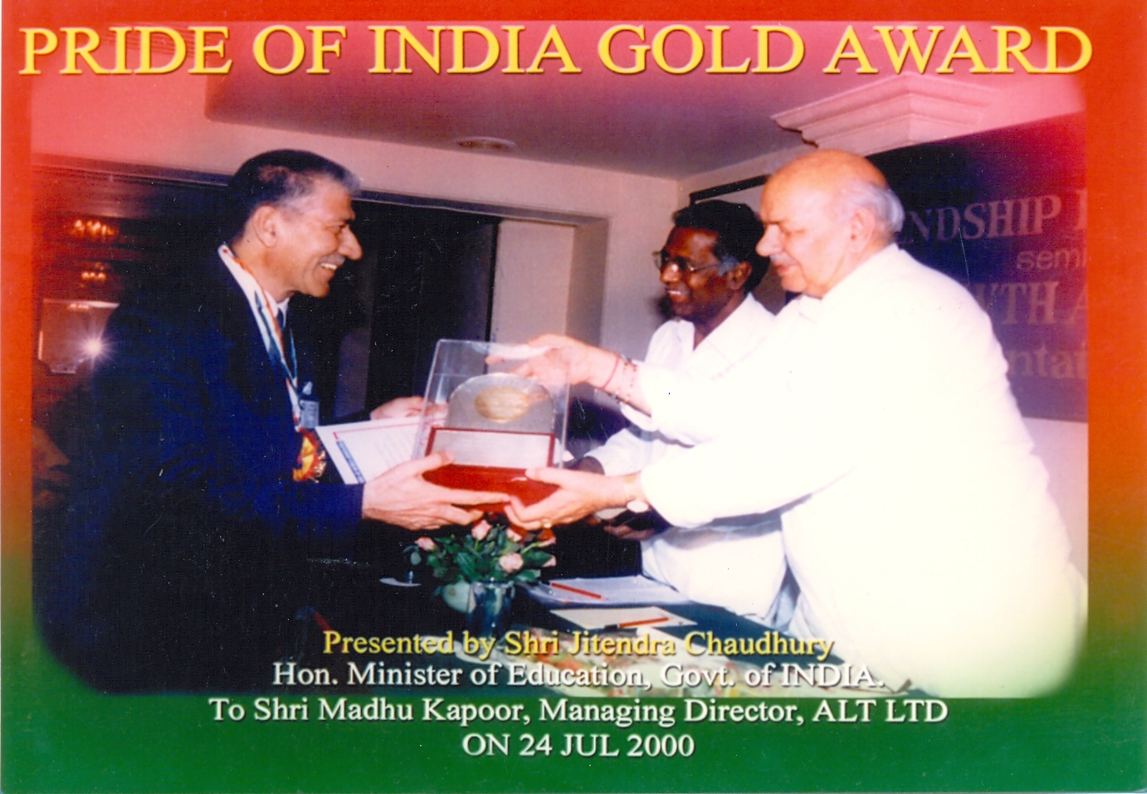
PRIDE OF INDIA GOLD AWARD
Presented by Shri Jitendra Chaudhary
Hon.Minister of Education, Govt of INDIA
To Shri Madhu Kapoor, Managing Director, ALT LTD ON 24 JULY 2000

