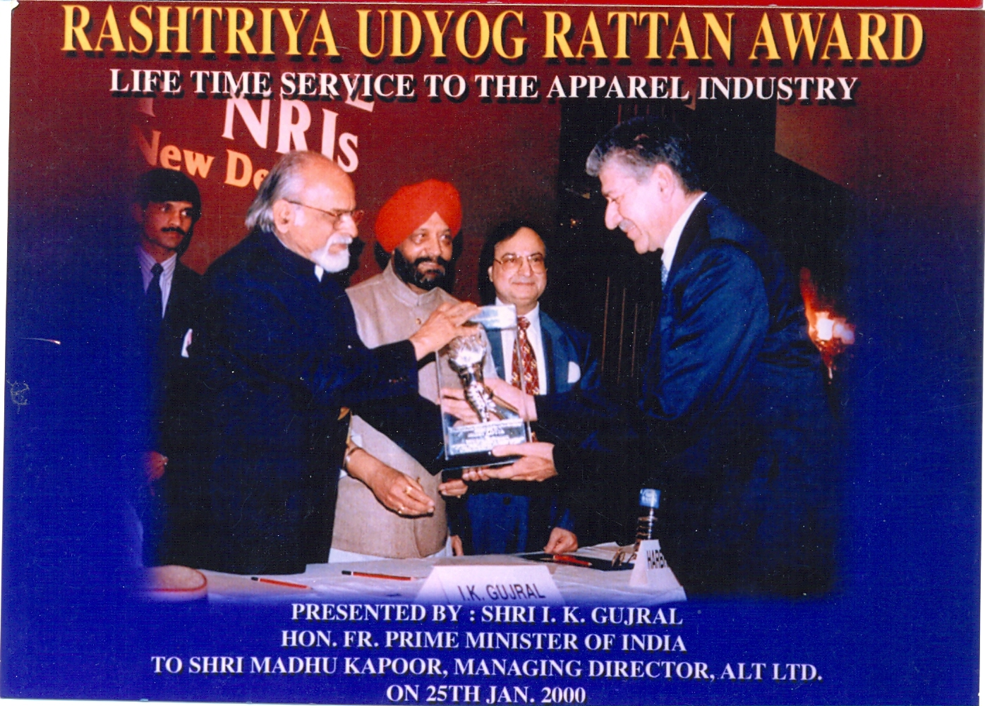
RASHTRIYA UDYOG RATTAN AWARD
LIFE TIME SERVICE TO THE APPAREL INDUSTRY
Presented by Shri I.K.Gujral
Hon.FR.Prime Minister of INDIA
To Shri Madhu Kapoor, Managing Director, ALT LTD ON 25th JAN 2000

