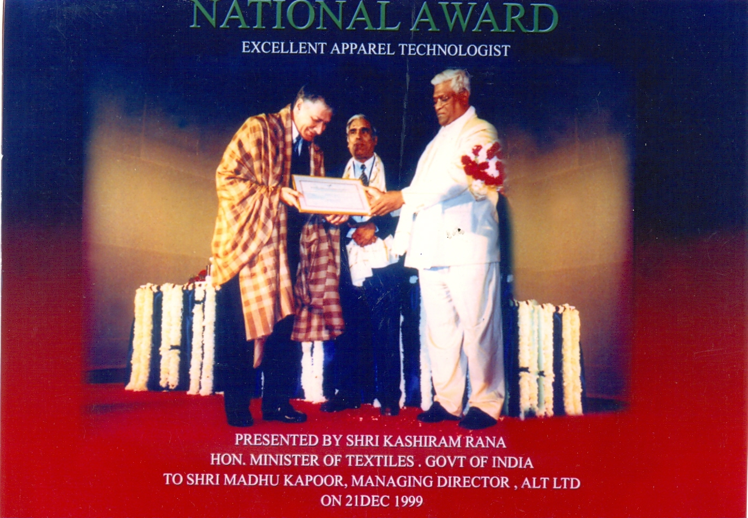
NATIONAL AWARD
EXCELLENT APPAREL TECHNOLOGIST
Presented by Shri Kashiram Rana
Hon.Minister of Textiles, Govt., of INDIA
To Shri Madhu Kapoor, Managing Director, ALT LTD ON 21 DEC 1999

